Image | 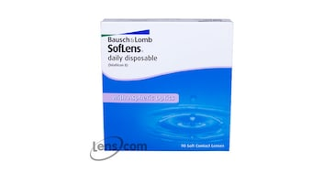
Brand | MICHEAL KORS
Model Name | BAUSH & LOMB SOFT LENS
Price | RS 1800
PRODUCT DETAILS

